**API Gateway**

**Go to AWS console**

**Select API gatewat 🡪 REST API**

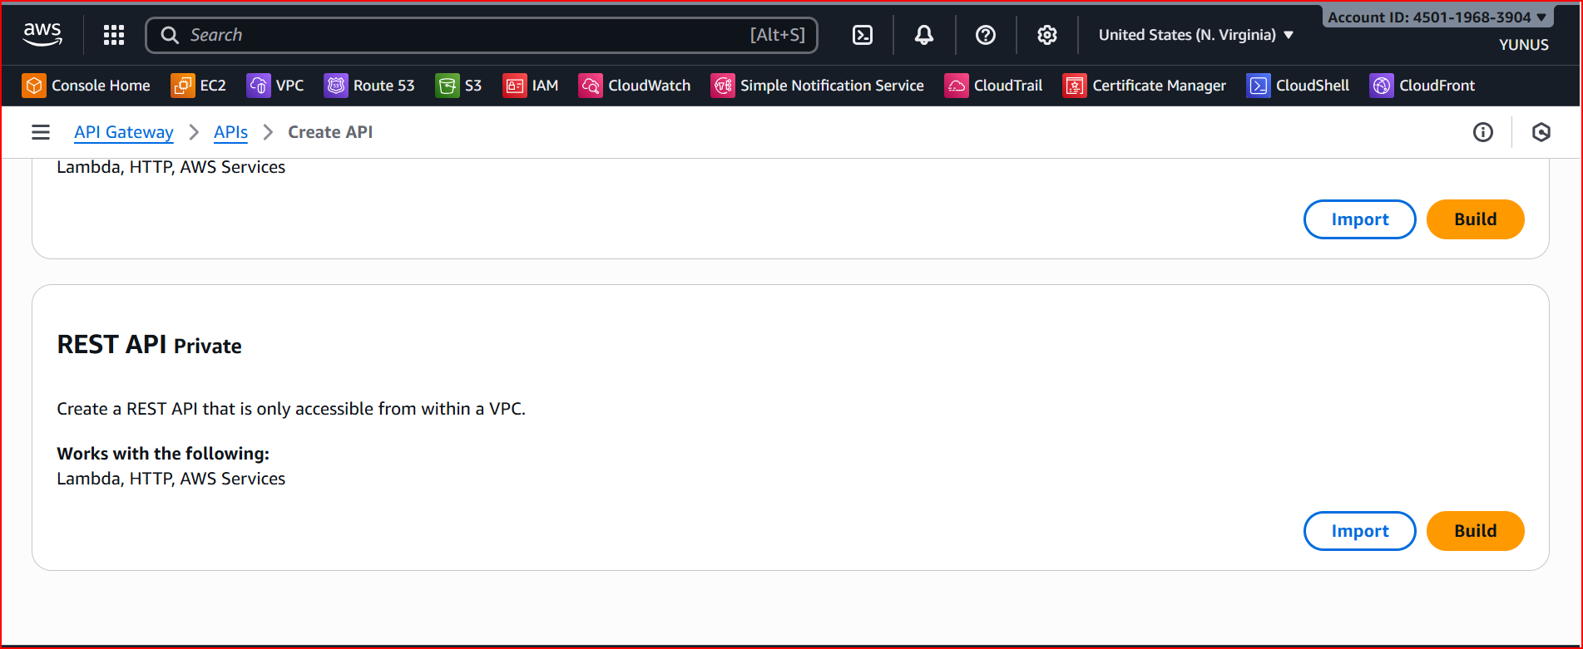

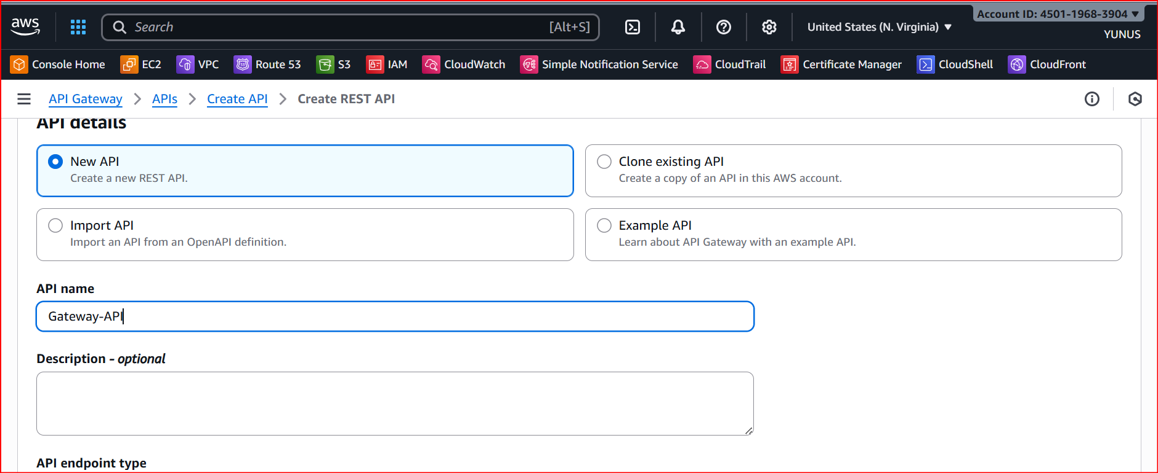

**Select the 🡪 API end point type**

**Regional**

**And create API**

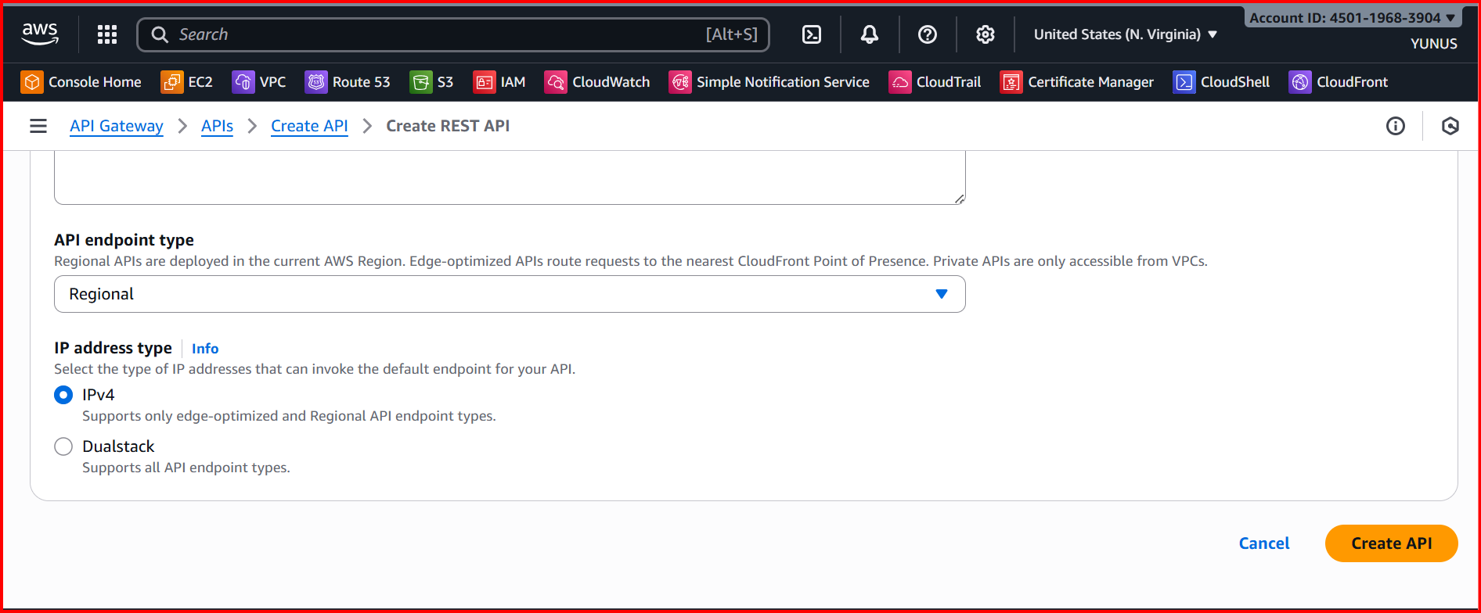

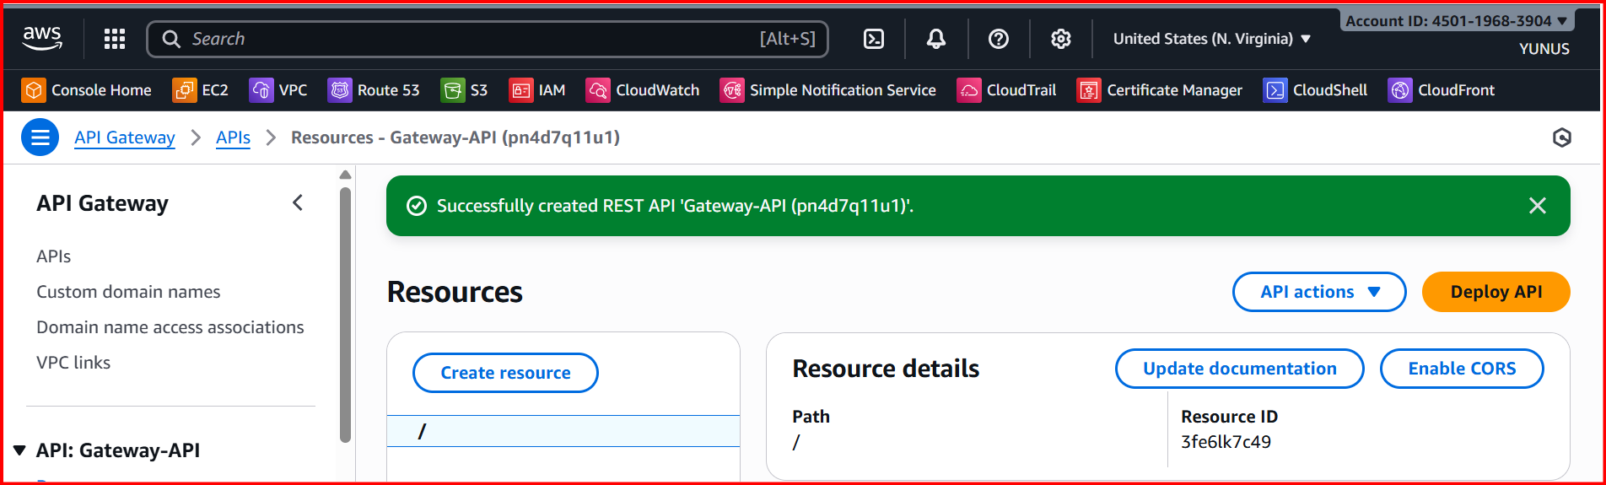

**Create Resources**

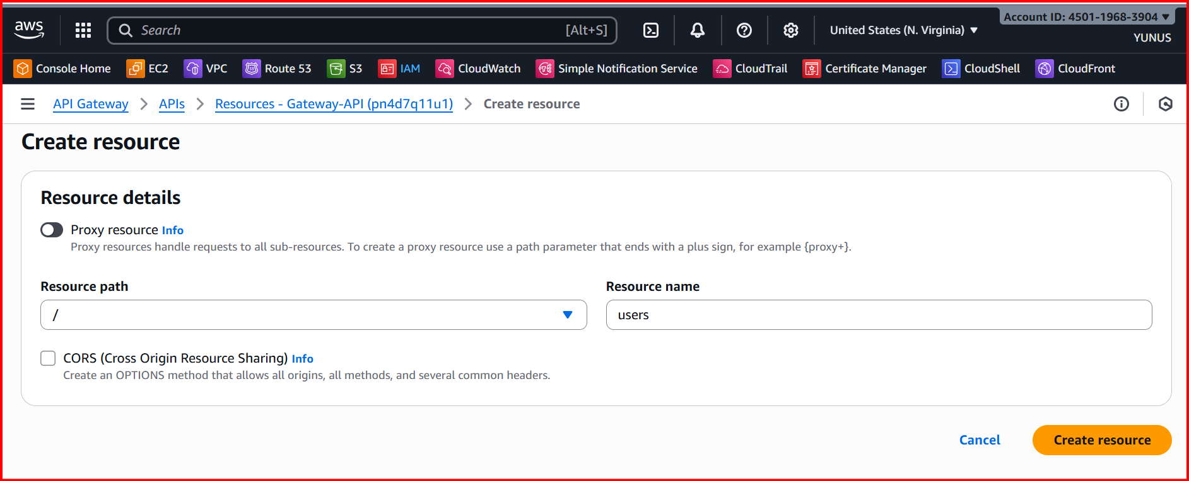

**Create Get Method**

**Click on method**

**Select Get**

**Select Integration type (ex:lambda)**

**Add the lambda function**

